#include <iostream>

#include <stdlib.h>

#define max 3

using namespace std;

struct gudang{

string nama,kategori;

int jumlah;

}barang[max];

int main()

{

char menu='\0';

int f=-1, b=-1;

do{

switch(menu){

case '1':

//INSERT

if(b<max-1){

if(f==-1){

f=0;

}

b++;

cout << "Nama Barang : "; cin >> barang[b].nama;

cout << "Kategori : "; cin >> barang[b].kategori;

cout << "jumlah Masuk : "; cin >> barang[b].jumlah;

}else{

cout << "barang queue Penuh !" << endl;

}

menu='\0';

system("pause");

break;

case '2':

//DELETE

if(b>=0){

cout << "Barang Berikut Keluar" << endl;

cout << "Nama Pengirim : " << barang[0].nama << endl;

cout << "Kategori : " << barang[0].kategori << endl;

cout << "jumlah Masuk : " << barang[0].jumlah << endl;

for(int i=0;i<b;i++){

barang[i]=barang[i+1];

}

b--;

if(b==-1){

f=-1;

}

}else{

cout << "barang queue Kosong !" << endl;

}

menu='\0';

system("pause");

break;

case '3':

//VIEW

if(f!=-1){

for(int i=0;i<=b;i++){

cout << "Barang barang queue ke-" << i+1 << endl;

cout << "Nama Pengirim : " << barang[i].nama << endl;

cout << "Kategori : " << barang[i].kategori << endl;

cout << "jumlah Masuk : " << barang[i].jumlah << endl;

cout << "======================\n\n";

}

}else{

cout << "barangueue Masih Kosong !" << endl;

}

menu='\0';

system("pause");

break;

default:

cout << "1. Insert " << endl;

cout << "2. Barang yg pertama Keluar" << endl;

cout << "3. View " << endl;

cout << "4. Keluar" << endl;

cout << "Masukkan pilihan menu (1-4) -> ";cin>> menu;

}

system("cls");

}while(menu!='4');

}

Input

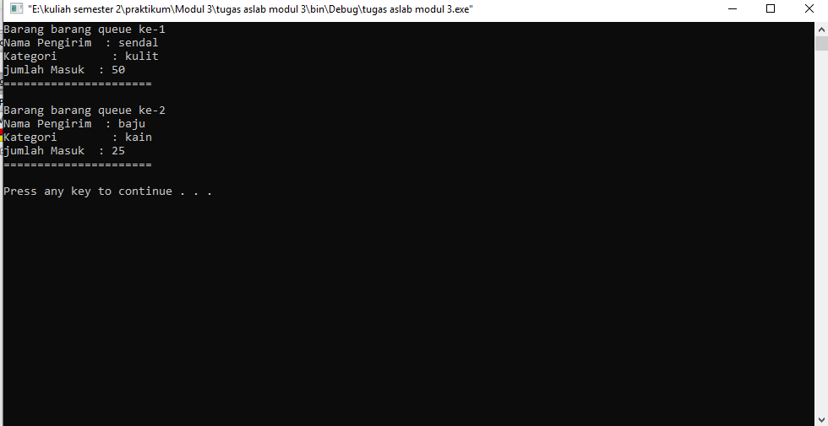

Output hapus

